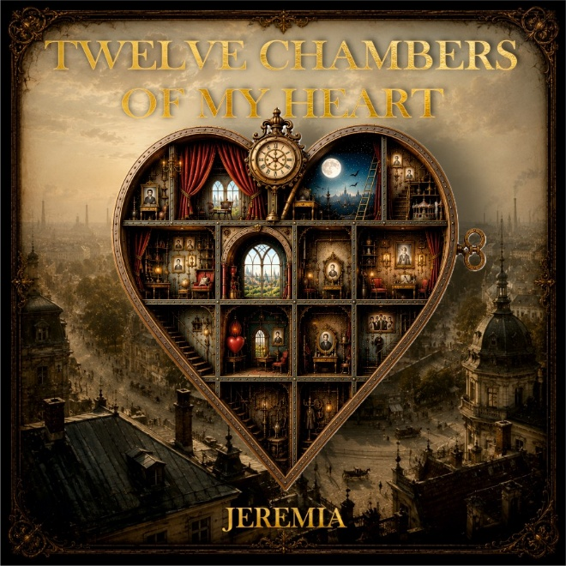
TWELVE CHAMBERS OF MY HEART
JEREMIA opens the doors to a house filled with stories
Twelve songs. Twelve chambers. A lifetime of stories.
With “Twelve Chambers of My Heart”, Viennese musician JEREMIA presents a concept album that reaches far beyond a collection of new songs. Music, words, images and personal memories come together to create a journey through an imaginary house – a house of the heart whose twelve chambers tell stories of encounters, love and loss, departure and homecoming, doubt, hope and moving on.
Nothing in this house is simply fiction. Its walls are built from lived experience.
Music has accompanied him for almost his entire life. He first appeared on stage at around the age of four, was playing electric guitar by seven, and by ten even had his own small PA system. Bands, original songs, recordings and productions followed. In 1986, he founded JEREMIA – initially as a band project, before the name gradually became his musical identity.
Forty years later, JEREMIA presents “Twelve Chambers of My Heart”, his second concept album. It is a work that contains not only four decades of JEREMIA, but the musical and personal experiences of almost an entire lifetime.
An album that becomes a house
“Twelve Chambers of My Heart” follows a deliberate dramatic arc. Each song opens another door and tells a story of its own, while all twelve pieces form part of a greater whole.
The journey begins with “Where It All Came From” and continues through songs including “Over the Ocean”, “Desire”, “Running”, “The Leaf and the Wind”, “1984” and “The Exiles”, leading the listener through very different rooms within the house.
Some of the stories are directly autobiographical; others transform lived experience into images and metaphors. A leaf and the wind tell a story of trust and letting go. Fairy-tale characters become exiles searching for a new home. Memory meets the present, and reality encounters imagination.
Musically, JEREMIA moves between rock and pop, singer-songwriter traditions and orchestral elements. Guitars meet piano, strings, wind instruments and electronic soundscapes. It is not a particular genre that holds the album together, but its narrative.
More than a booklet
For that reason, “Twelve Chambers of My Heart” does not end with the music.
Accompanying the album is an elaborately designed 28-page book, opening the twelve chambers visually as well as through words. Illustrations, personal texts, reflections and stories expand upon the songs and turn the album into a world that can be explored on paper.
It is deliberately not a conventional lyric booklet. The lyrics are presented separately. Instead, the accompanying book is intended as a guide through the Heart House – an invitation to look beyond the music and spend a little longer inside each of its rooms.
A continuous visual language connects reality, memory and imagination: doors and windows, old books, carousels, Vienna's Prater, a fox and, time and again, the Heart House itself. Many of these motifs have a personal significance and reappear like recurring characters throughout the different chapters.
Where stories and history meet
The project will receive its first complete presentation on 18 September 2026 at the Prater Museum in Vienna.
The choice of venue is anything but accidental.
For around 160 years, JEREMIA's family has been connected with Vienna's Prater. Generations of the family have lived and worked there. For this evening, the museum therefore becomes more than a venue – it becomes part of the story itself.
The presentation combines live music, film, images and storytelling. Rather than simply announcing songs, JEREMIA guides the audience from one chamber to the next, sharing the stories behind the music and allowing sound and imagery to merge into a single experience.
The result is less a conventional concert than a guided journey through “Twelve Chambers of My Heart”.
The evening also takes place in a significant year: 40 years of JEREMIA, a family connection with Vienna's Prater spanning generations, and a new chapter in a musical journey that began in early childhood.
“Every Heart Is a House of Stories”
At its heart, the idea behind the project is simple:
Every one of us carries a house filled with stories.
Some doors stand open. Some rooms we visit often. Others remain locked for years. Some stories we tell willingly – others perhaps never at all.
“Twelve Chambers of My Heart” opens twelve of those doors.
It is an album about one life – but at the same time an invitation for listeners to discover something of their own stories within those of another.
JEREMIA – Twelve Chambers of My Heart
Concept album · 2026
Live presentation:
18 September 2026 (6 pm)
Prater Museum Vienna
Album: Twelve Chambers of My Heart
Artist: JEREMIA
12 songs · 28-page accompanying book · illustrations · texts · live presentation
Press information, images, music and further material:
jeremia.art
gary@jeremia.art

